Step to Step Guide for Bush Primary School App

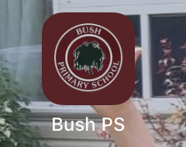

Download Bush Primary School App

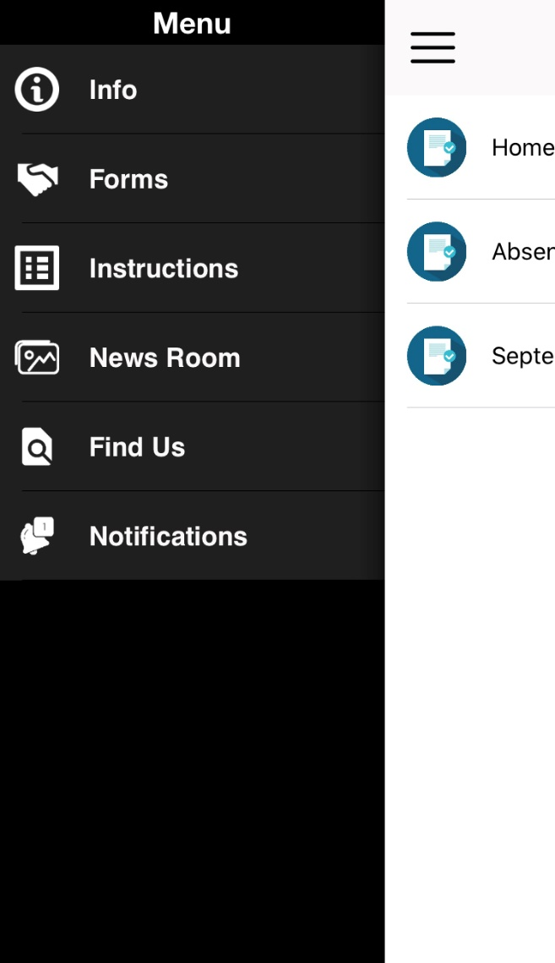

The menu bar will appear at the top of your screen.

If asked for a password, it is 11111

Please also complete the registration form.

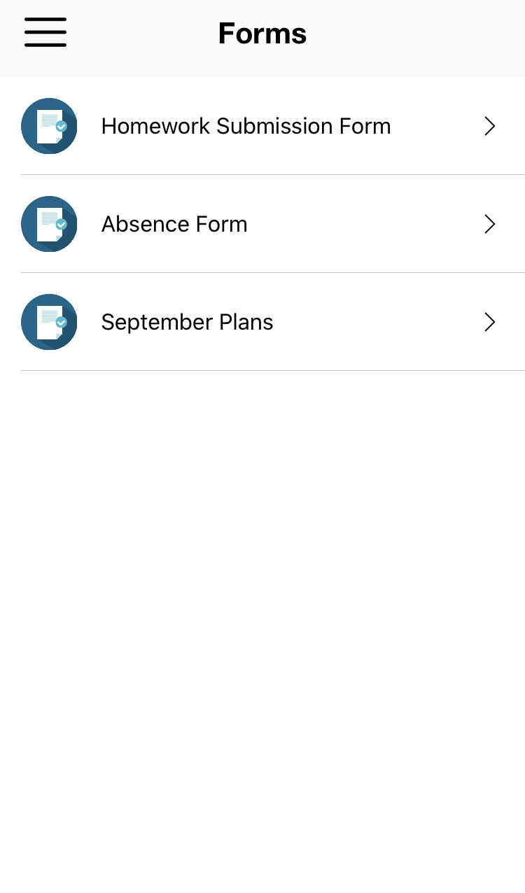

Absence Form (all notifications of absence should be sent this way.)

(You will be told when to use Homework Submission Form, September Plans no longer needed and shouldn’t appear)

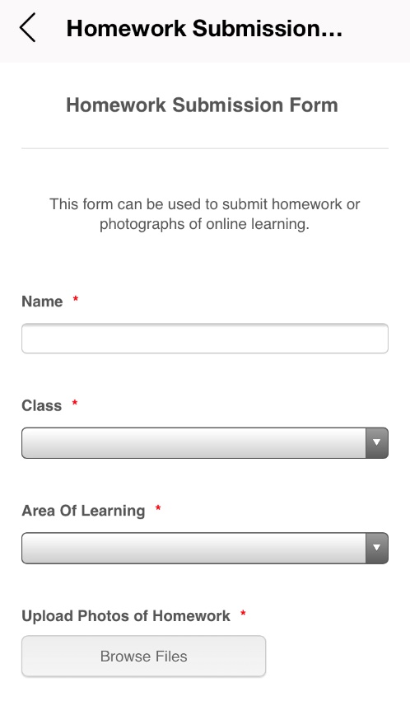

Homework Submission

Fill in your child’s name and select the class, areas of learning and upload photos of homework and send.

Each teacher will tell you when to use this.

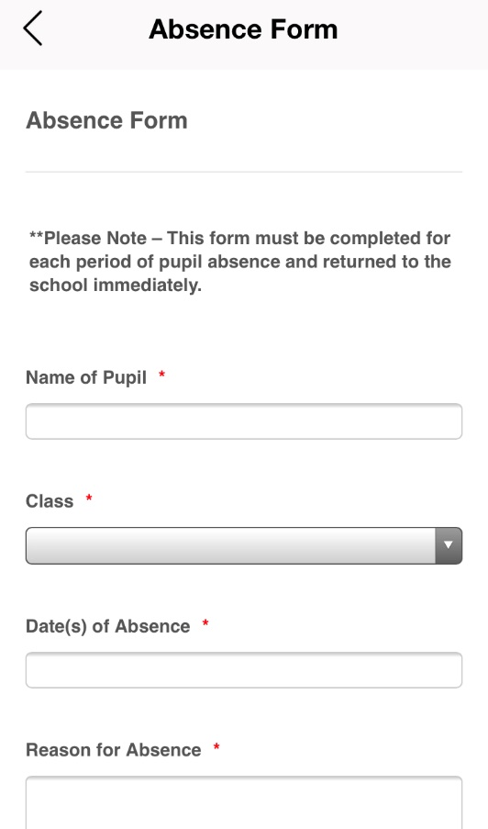

Absence Form

This form must be completed for each pupil absence and returned to the school.

It will come to the email of the class teacher and the Principal/Co-Principal.